

Team members

- Ahmed El-Gamal
- Youssef Mustafa
- Mayam Khaled
- Mariam Tarek
- Mostafa Fouad
- Nada Ahmed

Table of contents
- Project Planning & Management
- Requirements Gathering
- System Analysis & Design

.1Project Planning & Management

1.1Overview:
This project focuses on analyzing large public transport datasets in order to gain meaningful insights. The analysis is performed using cloud data warehouse platforms such as Snowflake, Amazon Redshift, or Google BigQuery, which provide scalable storage and efficient querying capabilities for large datasets.
The project aims to process transport data, explore its structure, and extract useful patterns that help in understanding transportation behavior.

1.2 Objectives:
- To analyze large transport datasets and extract insights
- To use cloud data warehouses for efficient data storage and querying
- To explore trends and patterns in transport data
- To support decision-making through analytical results

1.3Scope:
The project covers all stages from data ingestion of CSV files, data exploration and preprocessing, building analytical models using SQL queries, deploying data into cloud warehouses using batch processing, automating query execution, and finally presenting results through visualizations and reports.

1.4 Milestones Covered:
- Data Collection, Exploration & Preprocessing
- Model / System Development & Evaluation
- Deployment (Batch Processing)
- MLOps / Monitoring / Automation
- Final Documentation, Demo & Presentation

1.5 Project Plan
Project Duration: 5 Phases

Milestone 1: Data Collection, Exploration & Preprocessing
- Ingest transport CSV datasets into the system
- Perform data exploration to understand structure and properties
- Identify missing values, data types, and basic trends
- Prepare data for further processing

Milestone 2: Model / System Development & Evaluation
- Design analytical tables in the cloud data warehouse
- Develop SQL queries to analyze transport data
- Evaluate data structure for efficient querying and analysis

Milestone 3: Deployment (Batch Processing)
- Load cleaned data into cloud data warehouses such as BigQuery, Snowflake, or Redshift
- Use batch processing techniques for data upload
- Ensure data is properly stored and accessible for analysis

Milestone 4: MLOps / Monitoring / Automation
- Automate query refresh schedules for updated analysis
- Monitor data pipeline execution and performance
- Ensure consistency in data updates and processing

Milestone 5: Final Documentation, Demo & Presentation
- Prepare final documentation of the project
- Present interactive query results
- Display visual insights and dashboards based on analysis
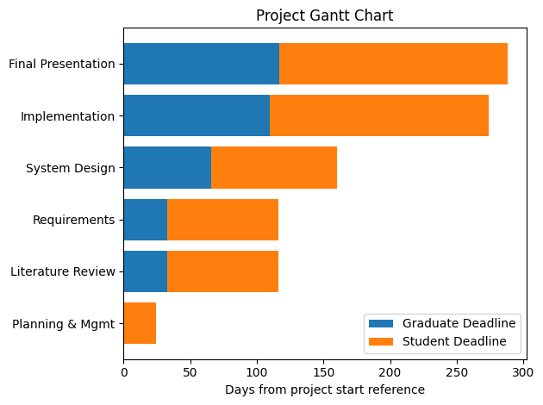

1.6Team Roles and Responsibilities: (We will modify it.(
Data Engineer:
Responsible for ingesting transport CSV datasets, performing preprocessing tasks, and loading data into the cloud data warehouse.
Data Analyst:
Responsible for exploring the dataset, writing SQL queries, and analyzing transport trends and patterns.
BI Developer:
Responsible for creating visual representations of the analyzed data and building interactive dashboards for presentation.
Project Manager:
Responsible for managing the overall workflow, ensuring milestone completion, and coordinating between team members.
Each member contributes according to their role to ensure successful completion of all project milestones.

1.7Risk Assessment & Mitigation Plan:

Risks:
- Data Ingestion Issues:
Problems may occur while loading CSV datasets into the system.
- Data Quality Problems:
Missing values or inconsistent data may affect analysis results.
- Query Execution Errors:
Incorrect SQL queries may lead to wrong analytical results.
- Deployment Challenges:
Issues may arise during batch loading into cloud data warehouses.
- Automation Failures:
Scheduled query refresh may fail or not execute properly.

Mitigation Plan:
- Validate data before and after ingestion
- Apply proper preprocessing techniques to clean data
- Test SQL queries before final execution
- Monitor batch processing during deployment
- Ensure automation schedules are properly configured and tested

1.8 KPIs :

Technical KPIs:
- Successful ingestion of all transport CSV datasets
- Accurate preprocessing and cleaning of data
- Correct execution of SQL analytical queries
- Successful deployment into cloud data warehouse

System KPIs:
- Successful batch processing without failures
- Proper execution of automated query refresh schedules
- Stable performance of data warehouse queries

Output KPIs:
- Clear identification of transport trends and patterns
- Accurate analytical results from queries
- Successful visualization of processed data

